Dear Guido,

To review, Credit One is seeing an increase in default rates which will likely result in the loss of customers. Credit One desires a better way to understand how much credit to allow someone to use or at very least if someone should be approved or not.

As I mentioned earlier, I am using Machine Learning modeling methods in an attempt to address these two desires and discuss them below:

1. How Much Credit to Give Someone:

In order to answer the question a conditional model needs to be executed: that is, holding all features fixed and adjusting the target feature (Credit Limit) to identify where the feature set changes from non-default to default. It is beyond my current expertise to execute such an analysis.

However; an analysis was conducted to try and understand Credit One’s current process. Using three Linear Regression algorithms (Random Forest Regressor, Linear Regression, and Support Vector Regression) I attempted to develop a model that could replicate their process to better understand their process. I set the Limit Balance as the target variable and ran various sets of features through the algorithms. After numerous attempts, I was unable to develop a satisfactory model with the highest r2 achieved being in the mid 0.40’s. See screenshot of all features below. In general, the less features used, the lower the r2.



A good model to better understand Credit Ones basis for establishing credit balance cannot be established.

1. How to improve selection process

As discussed, the second part of the question looks at improving upon the current model selection process. It is understood that the current model selection features only include Demographic Data and perhaps Payment Status data, then once a customer is determined ‘credible’ the Credit Limit is established. Since the provided dataset only includes those customers that were determined “credible”, it can be said that the current model has a 22% default rate since 22% of the customers in the dataset are defined as “default”. Another way to view this is that the current model has a precision rate of 78%.

Using several Conditional Regression algorithms (Random Forrest Classifier, Decision Tree Classifier, Support Vector Classification, and Gradient Boosting Classifier) with the Default/Non-Default variable as the target; I ran various sets of features through these algorithms and found the best result came from the 11 features of Credit Limit, Demographic Data (4 features), and Payment Status (6 features). The other features (Billing and Payment) did not produce any better results, hence were dropped. As such, from these 11 features, I was able to produce a couple of models that will perform better than the current selection model.

The one with the best overall confidence is the Gradient Boosting Classifier (BGC) algorithm with an 82% confidence level. This model is better at finding non-default (“credible”) candidates with a precision of 84%, which is 6 pts better than the current model’s precision of 78%. Risk of this model is that a third (34%) of those determined to be “non-credible” are actually credible; however, we do not know how this compares to the current model as that data is unknown.

If a more conservative model is desired by Credit One, then the Support Vector Classification (SVC) model provides a higher precision of 88% but has an overall confidence level of 76%. While this model will reduce the number of defaults selected, it will also reduce the overall number of customers selected, by about 18%, thus reducing revenue.

Results of the two models are shown below:

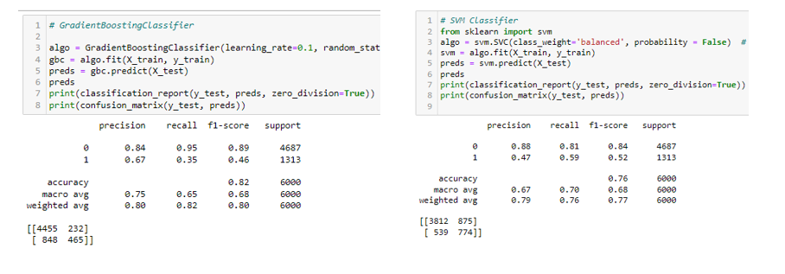

Both these models assume that the Payment Status of a customer is acquired or known during the application process. If not, suggest Credit One establish a process to get this information during the application process or some similar measure of. If a similar measure is to be used, then these models should be re-evaluated.

Lastly, the question was asked: how do we ensure that customers can/will pay their loans? The short answer to this is that there is no way to ensure a customer pays their bills. At best, Credit One can pursue legal measures which does not guarantee payment and increases company costs.

The better answer is to improve Credit One’s customer selection process and to better manage credit limits to prevent customer default.

Please let me know if there are questions or if further analysis is needed. I appreciate the opportunity to be of assistance in this matter.

Best Regards,

Bill